Gasoline blending occurs in oil refineries, where crude oil is processed and refined into more useful products, such as gasoline and diesel fuel. We will consider three products: super gasoline, regular gasoline, and diesel fuel. These can be made by mixing three different types of crude oil: crude 1, crude 2, and crude 3. Each product is distinguished by its octane rating, which measures the quality of the fuel, and its iron content, which is a contaminant in the gas. The crude oils each have an octane rating and iron content as well. The following table shows the required octane ratings and iron contents for each of the products, as well as the known octane ratings and iron contents of each of the crude oils:

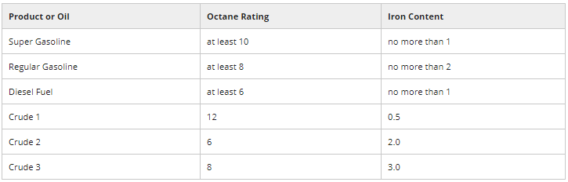

The gasoline produced must meet these standards for octane ratings and iron content. The octane rating and iron content of a product is the weighted average of the octane rating and iron content of the crude oils used to produce it.

The objective of the oil company is to maximize profit. The following table gives the sales price (revenue) for one barrel of each of the products:

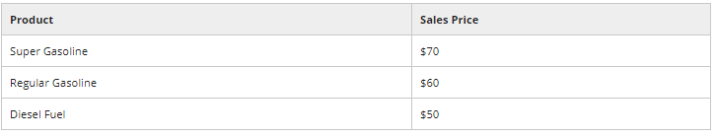

And the following table gives the purchase price for one barrel of each of the crude oils:

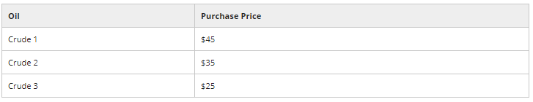

The company can only buy 5,000 barrels of each type of crude oil, and can process no more than 14,000 barrels total of crude oil. One barrel of crude oil makes one barrel of gasoline or fuel (nothing is lost in the conversion).

How many barrels of each type of crude oil should the company use to make each product? Formulate this problem as a linear optimization problem, and solve it in Excel.

Problem 1 - The Formulation

How many decision variables are there in this optimization model?

Answer: 9, one for each fuel/crude pair (so 3x3).

How many constraints are in the model, not including the non-negativity constraints?

Answer: 10; 3 for the octane ratings, 3 for the iron ratings, 3 for how much of each crude type can be purchased and 1 for the total amount of crude that can be purchased.

Problem 2 - The Solution

What is the objective value of the solution?

Answer: 375000

In the optimal solution, we produce the MOST barrels of which gasoline?  
Answer: We sum the columns in the Decision Variables table and see that the column correspond to Regular is the largest.

In the optimal solution, how many barrels of diesel fuel are produced?

Answer: 0

The company is unhappy with this solution, because they are exceeding the customer demand for regular gasoline. They estimate that the customer demand for super gasoline is 3,000 barrels, the customer demand for regular gasoline is 2,000 barrels, and the customer demand for diesel fuel is 1,000 barrels. They don't want to produce more than the customer demand, since they will lose revenue. Add constraints to your model to make sure that the solution produces no more than the customer demand for each of the products, and re-solve your model.

What is the objective value now?

Answer: 150000

Which of the crude oils are used in the solution?

Answer: Crude 1 and Crude 3

Problem 3- Sensitivity Analysis and Shadow Prices

The following are the shadow prices for each of the demand constraints:

Super gasoline demand shadow price = 29

Regular gasoline demand shadow price = 27

Diesel fuel demand shadow price = 9

The super gasoline shadow price holds to an allowable increase of 1250, the regular gasoline shadow price holds to an allowable increase of 2500, and the diesel fuel shadow price holds to an allowable increase of 1250.

What does a shadow price of 29 for the super gasoline demand constraint mean?

Answer: For one additional barrel of demand of super gasoline, the total profit will increase by 29.

According to the shadow prices, which type of gasoline should the company advertise to increase demand? Suppose that advertising costs $2 per unit increase in demand regardless of the type of gasoline being advertised.

Answer: Super gasoline, because it has the largest shadow price.

How much additional profit would you gain if the super gasoline demand increased by 500?

Answer: 500\*29 =$14500 if it is done freely; 500\*29-500\*2 =$13500 if done at an advertising cost of $2 per unit.

How much additional profit would you gain if you increased the super gasoline demand by 1500?

Answer: We have to rerun the optimizer by increasing the super gasoline demand by 1500 because this is above the allowable increase. Doing so we find a new profit of $192500, for a difference of $42500 above the original $150000.